|  |
| --- |
| Circle Language Spec: Inheritance |

## System Command Overriding By Extension

There is an alternative to overriding: you can implement the pre-extension event of a command and cancel the event.

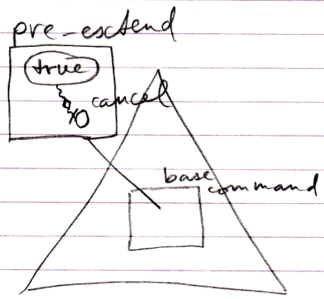

This cancels the execution of the base command.